Data Exploration & Insights
To gain a comprehensive understanding of the NCAA dataset and validate our preprocessing pipeline, we conducted targeted exploratory data analysis. The following figures justify our modeling decisions regarding class imbalance, time-series stability, and feature engineering.

1. Class Imbalance & Split Validation
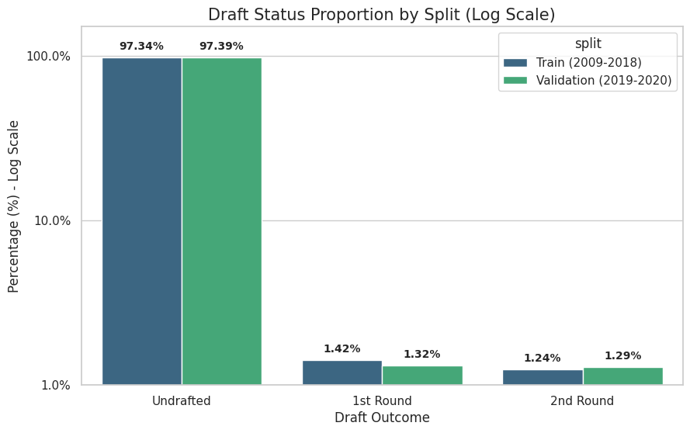
Method: We used a bar plot with a logarithmic scale to visualize the proportion of draft outcomes across our Training (2009-2018) and Validation (2019-2020) splits.
Justification & Insights: A standard plot completely hides the drafted players due to extreme class imbalance. By using a log scale, we uncovered two critical insights. First, the dataset is overwhelmingly skewed, with ~97% of players going undrafted. This explicitly justifies our decision to evaluate models using F1-score and AUROC rather than standard accuracy, and necessitates techniques like class_weight='balanced' during training. Second, the proportions between the Train and Validation sets are nearly identical (~1.3% for each draft round), proving that our chronological data splitting method preserved the underlying distribution without introducing selection bias.
2. Identifying the "Elite Cluster" & Outlier Management
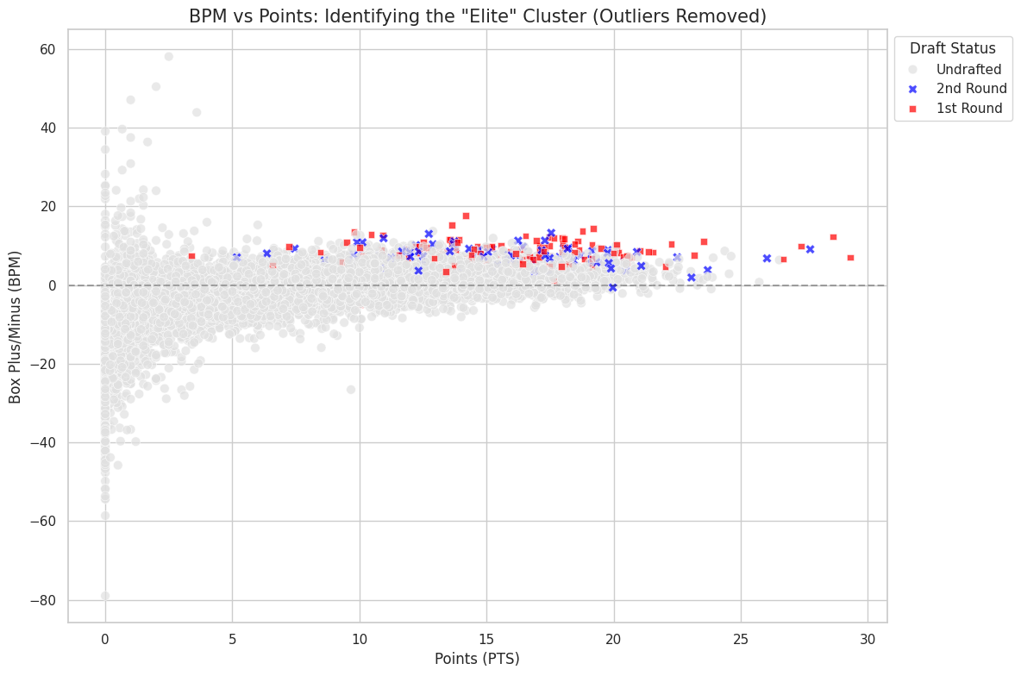
Method: We utilized a high-contrast scatterplot to examine the relationship between raw scoring (Points) and advanced efficiency (Box Plus/Minus, BPM) across different draft statuses, filtering out statistical anomalies (BPM > 30).
Justification & Insights: This visualization was crucial for understanding the decision boundary between professional prospects and regular college players. The plot reveals a clear "Elite Cluster" in the upper-right quadrant (high PTS, high BPM) dominated by 1st-round picks (red). However, the overlap of undrafted players (gray) in this exact same high-performance region justifies our choice to implement a non-linear Multilayer Perceptron (MLP). A simple linear model would fail to distinguish between these players, indicating that draft likelihood depends on deeper feature interactions (e.g., physical attributes or conference strength) rather than just scoring and efficiency. Furthermore, initial plotting revealed extreme data-entry errors (e.g., BPM > 700), justifying our rigorous data-cleaning phase to ensure model robustness.

3. Time-Series Stability & Contextual Anomalies
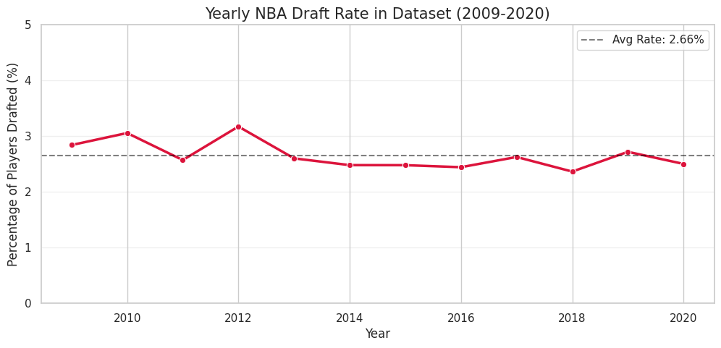
Method: We plotted a time-series line graph tracking the percentage of drafted players per year from 2009 to 2020.
Justification & Insights: Since our evaluation strategy relies on predicting future outcomes based on historical data, we needed to ensure the "draft rate" is relatively stable over time. The plot confirms a stable historical average of around 2.55%. However, it highlights a noticeable dip in the draft rate during the 2020 season. This insight is crucial for our subsequent Error Analysis, as it suggests the 2020 validation set contains external anomalies (e.g., the COVID-19 pandemic affecting NCAA seasons), which might explain potential performance drops or higher False Positive rates when predicting that specific year.

4. Validation of Engineered Features
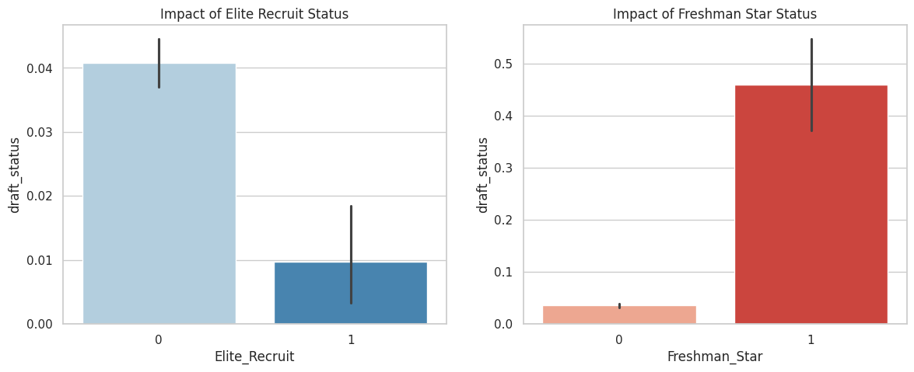
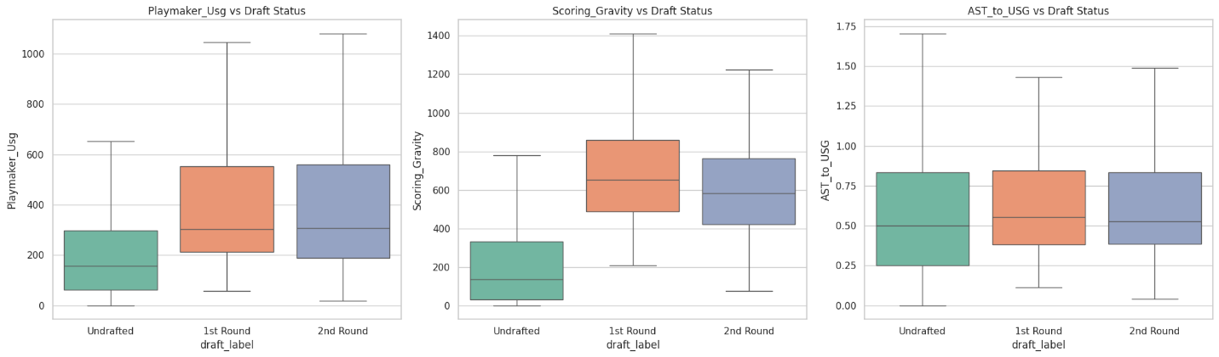
Method: We utilized comparative boxplots for continuous variables and categorical bar plots for binary indicators to evaluate the predictive power of our newly engineered features.
Justification & Insights: We needed to justify whether engineered features like Freshman_Star, Elite_Recruit, and Scoring_Gravity provide meaningful signals to the model. The visualizations strongly confirm their validity. For instance, the bar plots show that players flagged as "Freshman Stars" or "Elite Recruits" possess a dramatically higher probability of being drafted compared to the baseline. Similarly, the boxplots reveal a clear upward trend in medians for Scoring_Gravity and Playmaker_Usg as draft status improves. These figures justify our feature engineering efforts and confirm that these variables successfully capture complex scout-level evaluations (like "playmaking usage") that raw statistics miss.

